**TASK 2: Provision an EC2 Instance and Associate a Domain Using OpenSSL**

***(LAUNCH AN EC2 INSTANCE)***

**1-Successfully launched an ec2 instance by configuring inbound and outbound rules allowing HTTP and HTTPS**

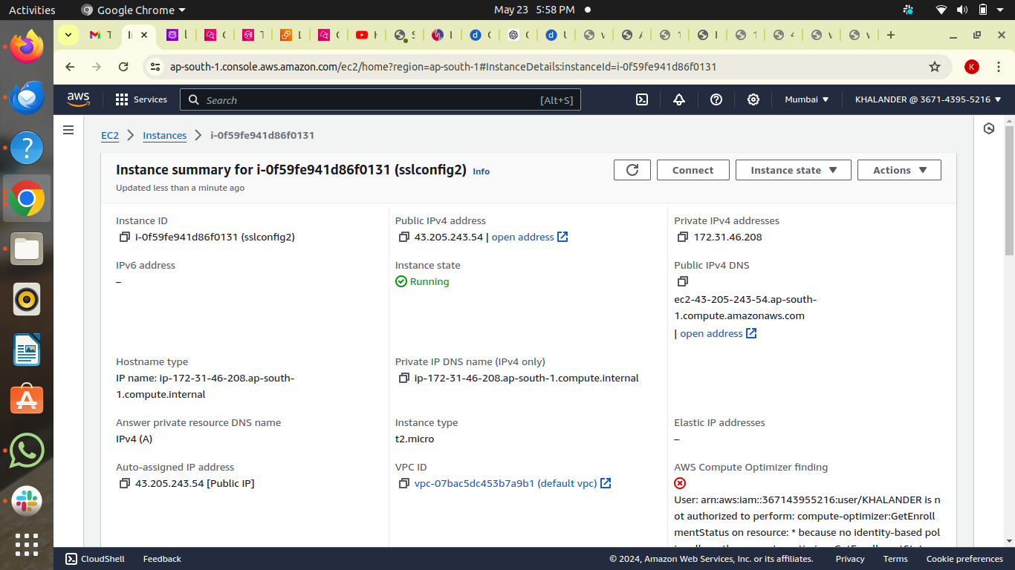

**2-Connected with an ubuntu terminal using ssh(ssh -i key.pem ubuntu@instanceip)**

***(INSTALLING OPENSSL)***

**1-Successfully Installed openssl using apache 2 server and did all the configuration in ssh-config file** 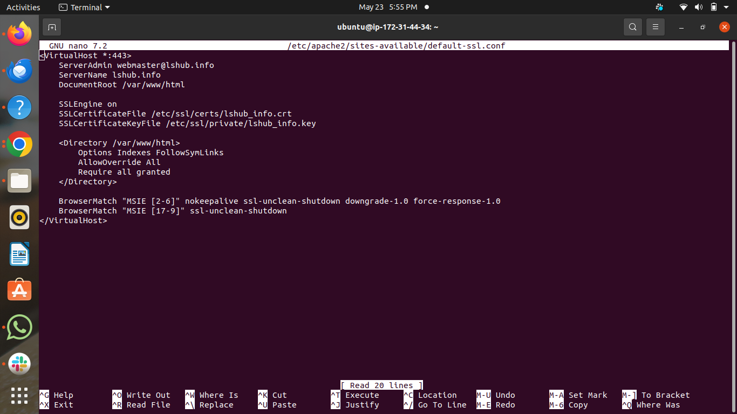

***(CREATING RECORD IN ROUTE 53)***

**1-Created an A record in route53 by attaching instance id to point a domain**

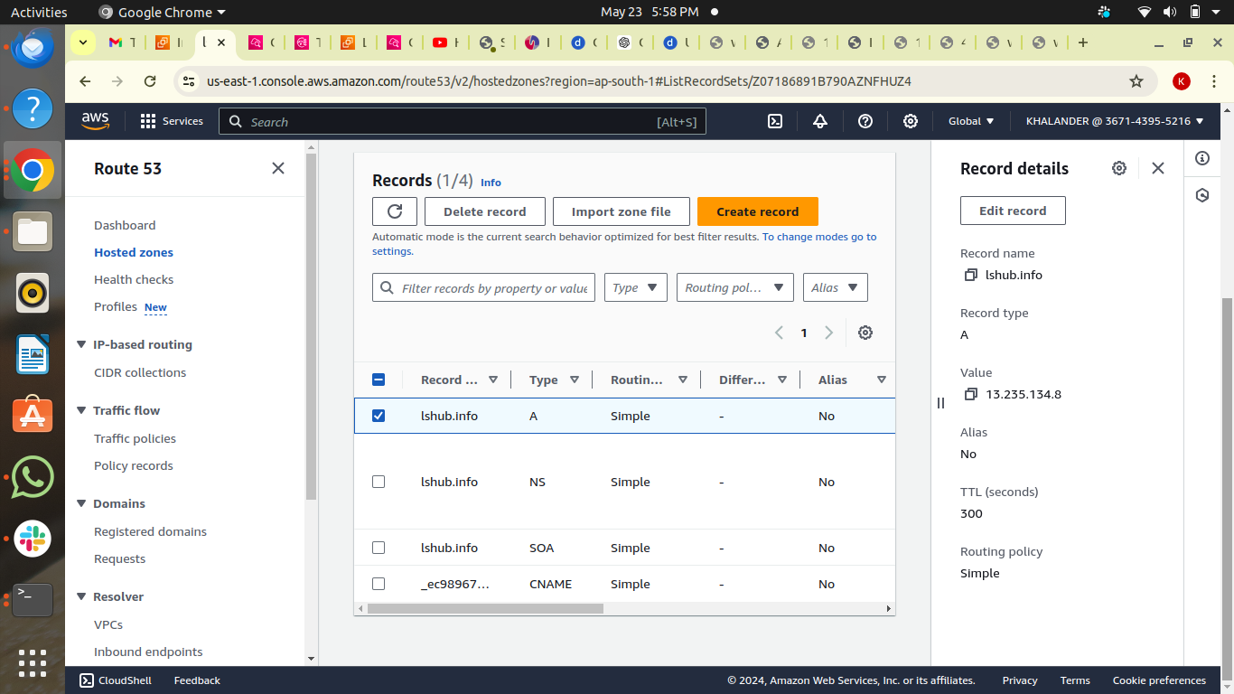

**(GENERATED SSL AND TLS CERTIFICATE)**

**1-Successfully generated SSL AND TLS certificate to configure it in a ssh-config file**

**(TESTING A WEBSERVER)**

**1-After doing all installation and configuration restarted an apache server and tested a Domain lshub.info**

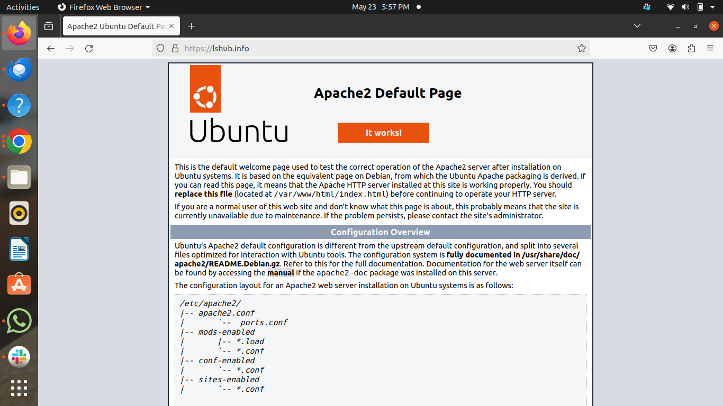

**OUTPUT**

**By following these steps, I had successfully provision an EC2 instance and associate the domain** lshub.info **with it using OpenSSL for SSL/TLS certificate management.**